EASTERN INTERNATIONAL UNIVERSITY Practice Assignment – Quarter 3, 2024-2025
SCHOOL OF COMPUTING Course Name: Database
AND INFORMATION TECHNOLOGY Course Code: CSE 301
Student’s Full Name: Nguyễn Khắc Duy
Student ID: 2131220021
Practice Assignment 8

Instructions:
- This paper consists of 2 sections. This paper carries 100 marks
- Section 1 (40 marks) includes 2 questions. Question 1 carries 30 marks, question 2 carries 10 marks.
- Section 2 (60 marks) includes 2 questions. Each question carries 30 marks.
- How to save the result:
  - All questions of section 1 and question 2 of section 2 are saved in the same Full-name.pdf file (converted from word file)
  - Section 2 question 2 is saved in a file Full-name.sql
---------------------------------------------------------------------------------------------------------

Section 1 (40 marks)
Section 1/Question 1 (30 marks)
The database for managing a student records system is designed to meet the following requirements: The system stores information about students, including student ID, full name, date of birth, gender, address, phone number, and email. Each student is assigned to a class, which is identified by a unique class ID, class name, academic year, and homeroom teacher. The school offers multiple courses, each with a unique course ID, course name, number of credits, and assigned teacher. Students can register for several courses, and each course registration includes the student ID, course ID, registration date, and academic term. Courses consist of multiple assessments such as midterms, final exams, or projects, each identified by an assessment ID, type, weight (as a percentage of the final grade), and due date. The system records student scores for each assessment, and these scores are used to calculate the final grade for the course. If a student misses an assessment, a make-up assessment can be recorded, linked to the original one, and includes a new scheduled date and grade. Final grades are calculated based on the weighted average of all assessments completed by the student in the course.

Using Draw.io (app.diagrams.net) perform the following requirements:
- Identify Entities with attributes and the relationships between entities;
- Design an ER- Diagram to the above schema management;
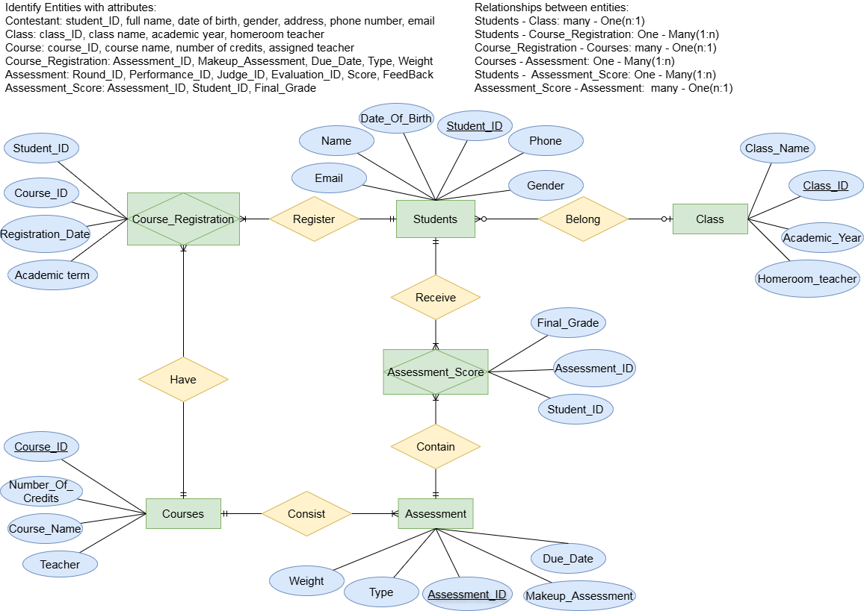
Section 1/ Question 2 (10 marks) using Equation on Microsoft Word:
Given a set of functional dependencies F on the relation schema R(U, V, W, X, Y, Z):
F = { U → VW, V → W, UV → X, X → Y, VY → W }
find the Canonical Cover (Minimal Cover) of $F$.

Step 1:
FD: F’ = { U → V, U → W, V → W, UV → X, X → Y, VY → W }
Remove U → W (We can infer from U → V, V → W (R3))
F’’ = {U → V, V → W, UV → X, X → Y, VY → W }

Step 2:
+ For U → V:
Considering U → V, (U)⁺ = {U, V, W, X, Y}
Ignoring U → V, (U)⁺ = {U, W}
- Essential, not remove
+ For V → W:
Considering V → W, (V)⁺ = {V, W}
Ignoring V → W, (V)⁺ = {V}
- Essential, not remove
+ For UV → X:
Considering UV → X, (UV)⁺ = {U, V, X, Y, W}
Ignoring UV → X, (UV)⁺ = {U ,V, W}
- Essential, not remove
+ For X → Y:
Considering X → Y, (X)⁺ = {X, Y}
Ignoring X → Y, (X)⁺ = {X}
- Essential, not remove
+ For VY → W :
Considering VY → W , (VY)⁺ = { V, Y, W}
Ignoring VY → W , (VY)⁺ = {V, Y, W}
- Remove because two result are the same

=> F’’’ = { U → V, V → W, UV → X, X → Y}

Step 3:
Considering UV → X:
(UV)⁺ = {U, V, X, Y, W}
(U)⁺ = {U, V, W}
(V)⁺ = {V, W}
- Essential, not remove

Conclusion: Minimal cover of F is: { U → V, V → W, UV → X, X → Y}

Section 2 (60 marks)
Use sql script in the file is provided to generate electronicstore database. Then use “Reverse Engineer…” tool on MySQL Workbench to create relational model from this database. Do these following tasks:
Section 2/ Question 1 (30 marks): Using Relational algebra to write the following queries (by using Equation on Microsoft Word):
- Insert a new product called "Apple Vision Pro" into the product table, and add it to store S001 in the storestock table with a quantity of 50.
product ← product ∪ { ('P1006', 'Apple Vision Pro') }
storestock ← storestock ∪ { ('S001', 'P1006', 50) }
- Update the quantity of each product in StoreStock by subtracting the total quantity sold across all stores for that product.
storestock ←

- Retrieve the store name, product name, and total quantity sold for all transactions where the selling price is greater than 20,000,000 VND and total of quantity sold greater than 2. Use projection (π), selection (σ), and natural join (⨝) in the query.

Section 2/ Question 2 (30 marks): Using MySQL to write the following queries.

